Joanne Hall: “The Swedish Art Weaves”
THE WARPS ARE HERE!
Now for rigid heddle OR 4 harness looms!!
June 8, 9 and 10, 2018 Hosted by the Skagit Valley Weavers Guild
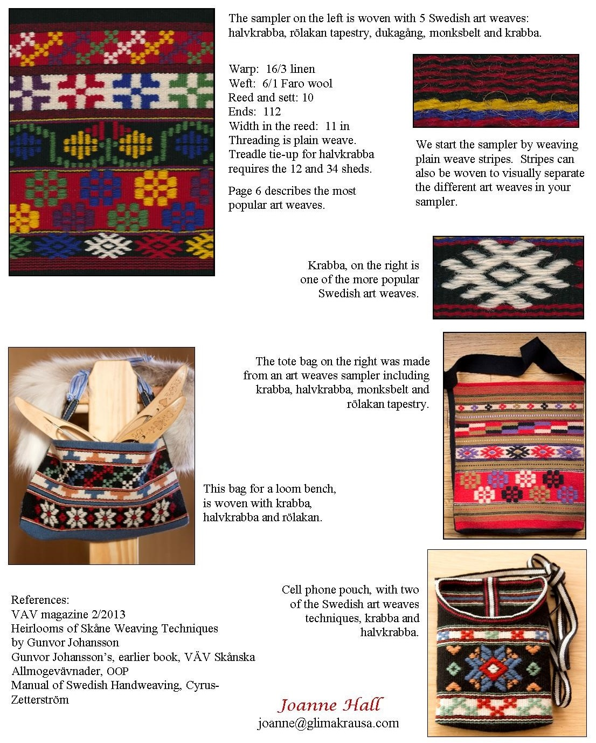
Contact Sharon Allen at Sharon.newchapter@gmail.com for more information.
The cost for this three day workshop with 16 attendees (we can take 20)
is $120.00 plus the $20-40 supply fee.

