Countermarche Loom Seminar with Joanne Hall, Bellingham, WA
Friday and Saturday, October 5 & 6, 2018, 9 am – 4 pm, $125
Oct 7 loom consultations by arrangement

Weavers with Countermarche looms love the ease of treadling and ergonomic comfort these looms provide. However, countermarche and counterbalance looms can have the reputation of being intimidating.
Beginning to advanced weavers, including those considering acquiring a countermarche loom, or setting up an inherited loom will benefit from this opportunity for hands-on learning with teacher, weaver and loom expert Joanne Hall. Three different countermarche looms will be warped and readied for weaving during the seminar. Other types of looms may be covered as time allows.

Topics included:
- Understanding and getting the most from your Countermarche loom
- Everything you wanted to know about warping but were afraid to try on your own.
- Introducing the traditional Swedish weavers’ coffee break: “Fika”

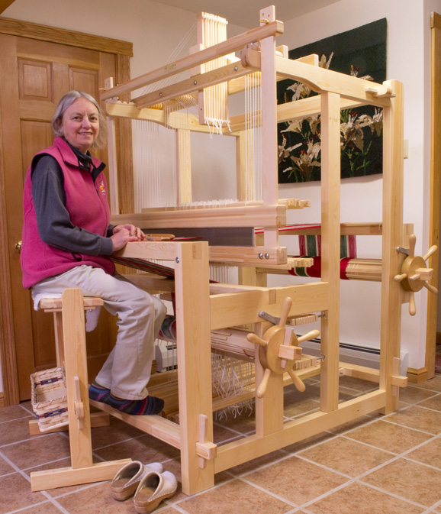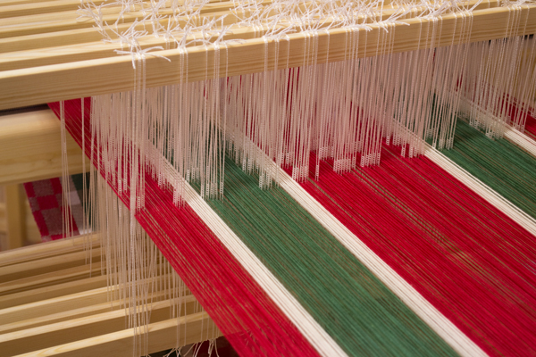

Additional topics can be included by request, as time allows. Studio visits/countermarch loom
consultations for weavers within reasonable driving distance can be arranged.

Friday and Saturday, October 5 & 6, 2018, 9 am – 4 pm, Oct 7 by arrangement
Workshop Limited to 6 participants each day. Registration preference given for both days.
Cost: $125 – two days, $75 – one day (Friday or Saturday) Sunday cost arranged
Cost Includes “Fika” – traditional Swedish weavers coffee break.

Register with Carol Berry, handwoveninbellingham@gmail.com, (360)920-6152

Location: The home weaving studios of Carol Berry and Judith Sen, located in the historic York and Sehome neighborhoods of Bellingham, WA

Countermarche Loom Seminar with Joanne Hall, Bellingham, WA

Friday, October 5, 9 am – 4 pm
Understanding the Countermarch Loom
- Understanding the balance of the countermarche loom
- Drafting for the countermarche loom
- Winding warps for the countermarche loom
  - Warping boards, reels, direct warping
  - Measuring a warp, winding on with even tension and avoiding tangles
  - More than 4 threads: Warping with a paddle
  - Long warps and fine threads
- Beaming and threading for efficiency and comfort
- Fika: Coffee Break, with Swedish treats
Saturday, October 6, 9 am – 4 pm
Countermarche with 4 to 8 shafts and more
- Updating an older loom to the texsolv system, all or part? – when, why and how to convert to Texsolv.
- Translate the three most common tie-up notations to countermarche tie up
- Treadle tie-up for countermarche
- Perfecting sheds for easy weaving
- Efficient & comfortable weaving
- Troubleshooting and repair for your loom

Sunday, October 7, Time & Location arranged
Studio visits for countermarche loom consultation for looms/studios within 30-minute driving distance. Topics can include set-up, evaluating a used or older loom, trouble-shooting, repair, warping, tie-up, moving a loom.

Countermarche Loom Seminar with Joanne Hall, Bellingham, WA
Friday and Saturday, October 5 & 6, 2018, 9 am – 4 pm, Oct 7 by arrangement
Workshop Limited to 6 participants each day. Registration preference given for both days.

Register with Carol Berry, handwoveninbellingham@gmail.com, (360)920-6152
1007 E. Maple St. Bellingham, WA, 98225
Cost: $125 – two days, $75 – one day (Friday or Saturday) Sunday cost arranged
Cost Includes “Fika” – traditional Swedish weavers coffee break.
Bring your own lunch. Microwave and refrigerator available.
Accommodations needed for out-of-town participants? Contact Carol with your needs, for available options.

